HW: 1) PB p.85 (r,tr), 2) WB p.72, 3) words – to learn
4) письменно описать картинку (как делали устно в классе по схеме)
5) по желанию – нарисовать свой зоопарк с животными, названия которых прошли

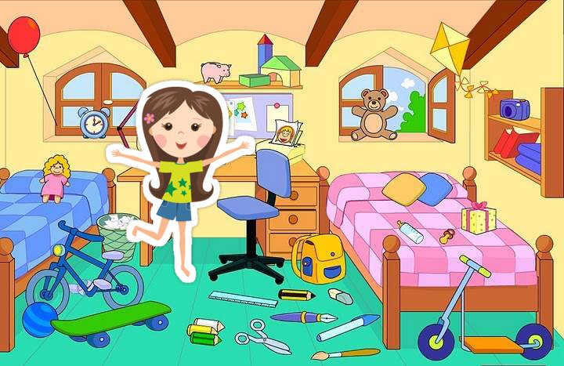
I can see (There are) 5 people in the picture. They are in the park/in the room/at home. The girl is playing the guitar. She isn’t singing. I think she plays the guitar well. I think she always plays the guitar. She is beautiful. She is wearing a white T-shirt, a pink skirt and pretty sandals.
There are two boys. They are laughing. One boy has got a toy train. He is playing with it. His train is green. He is wearing a blue shirt and black shorts.
One man is drinking tea. He has got a big red cup. There is bread on his plate. He is smiling. He is happy.
There are many flowers, they are red, yellow and purple. The weather is nice. The sun is shining. It isn’t raining.

Unit 8
- A monkey - обезьяна
- A giraffe - жираф
- A lion - лев
- A hippo – гиппопотам, бегемот
- A zebra - зебра
- A crocodile – крокодил
- An elephant - слон
- A neck – шея
- An ear - ухо
- A mouth - рот
- A tooth-teeth зуб – зубы
- Long - длинный
- Look over there! – Посмотри туда!
- Hot - жарко
- Today – сегодня
- Yesterday – вчера
- A half – половина

