HW
- PB p.70 – read, translate
- PB p.71 ex.1, 2
- Balloons – write the numbers
- New words – выучить, прописать (частично), полный список дан в конце файла
- Music man – слова прочитать

HW 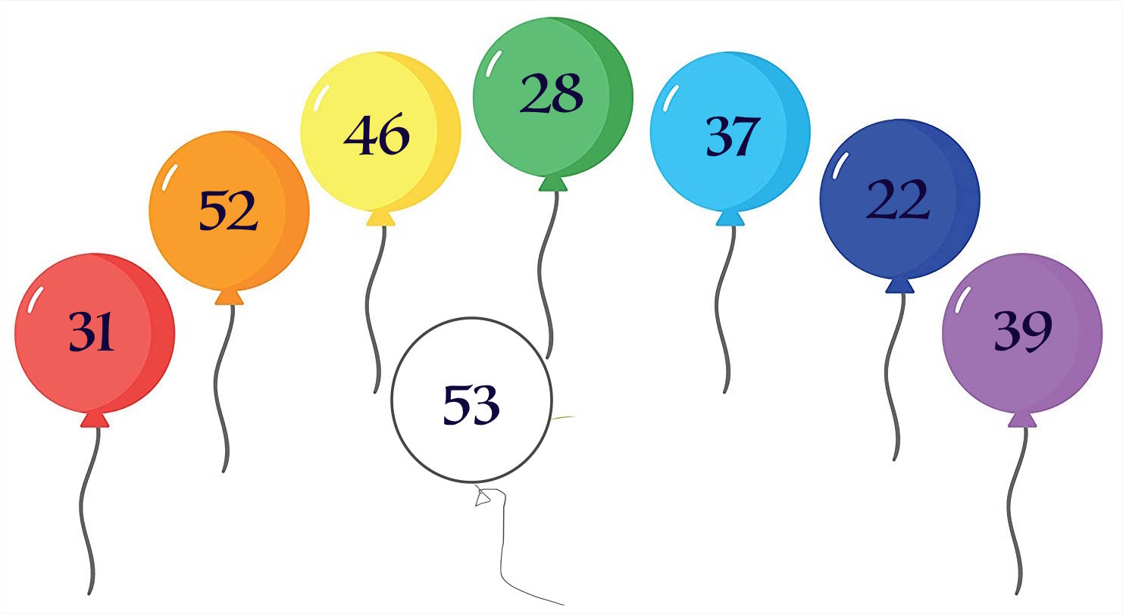

Write the number on the ballon as in the example:

Example: The white balloon's number is fifty-three.

- _______________________________________________
- _______________________________________________
- _______________________________________________
- _______________________________________________
- _______________________________________________
- _______________________________________________
- _______________________________________________

I AM THE MUSIC MAN
Everybody clap your hands in the air
And follow the music man!
I am the music man
I come from down your way
And I can play
What can you play?
I play piano

I am the music man
I come from down your way
And I can play
What can you play?
I play the trombone

I am the music man
I come from down your way
And I can play
What can you play?
I play the bagpipes
Trombone!
I am the music man
I come from down your way
And I can play
What can you play?
Match of the Day!
Bagpipes!

I am the music man
I come from down your way
And I can play
What can you play?
Well, I play the Dambusters
Here we go, here we go, here we go
Here we go, here we go, here we go
Here we go, here we go, here we go
Here we go, here we go, here we go
I am the music man!

Unit 6
- An arm рука
- A leg нога
- A foot-feet ступня-ступни
- A head голова
- A nose нос
- A competition соревнование
- A winner победитель
- To ride a bike кататься/ездить на велосипеде
- To walk on hands ходить на руках
- A toy игрушка
- Fantastic фантастический
- A rabbit кролик
- Whose чей [huːz]
- Be quiet тише! (=будь тихим)
- A band группа (зд. Музыкальная)
- To hear слышать
- The drums барабаны [drʌmz]
- To clap your hands хлопать в ладоши
- To stamp your feet топать ногами
- To wave your arms махать руками
- To shout кричать
- A trumpet труба [ˈtrʌmpɪt]
- Tiny крошечный [ˈtaɪnɪ]
- Gold золотой
- Shiny блестящий [ˈʃaɪnɪ]
- A flute флейта [fluːt]
- Silver серебряный [ˈsɪlvə]
- The shoulder – shoulders плечо-плечи
- To hold tightly держать крепко [ˈtaɪtlɪ]
- To shine brightly ярко сиять/блестеть [braɪtlɪ]
- Here is ….. – Вот …
- To come to приходить к

