EW4 задания на урок
- The smallest is ____________________________________
- They are not as ______________________________but slowly their _____________________________appear
- ________________________, these beautiful birds are in _________________________
- ______________________ can see well __________________________so they can catch fish __________________________
- The parents can _______________________________________when they are very young
- Many water birds __________________________________these
- ______________________can ___________________________from the sea easily because they have ______________________________
- ___________________________________when they dive in the water and the birds _____________________
- After a year, they are ______________________________
- __________________build the most ____________________________in plants near the water

- Удивительный________________________________________
- Крючковатый________________________________________
- Ловушка________________________________________
- Огромный________________________________________
- Рыболовное судно________________________________________
- Птенец________________________________________
- Клюв________________________________________
- К сожалению________________________________________
- Сеть________________________________________
- Быть в опасности________________________________________
- Легко________________________________________
- Нырять________________________________________
- Путешественник________________________________________
- Задерживать, поглощать воздух________________________________________
- Хватать рыбу________________________________________

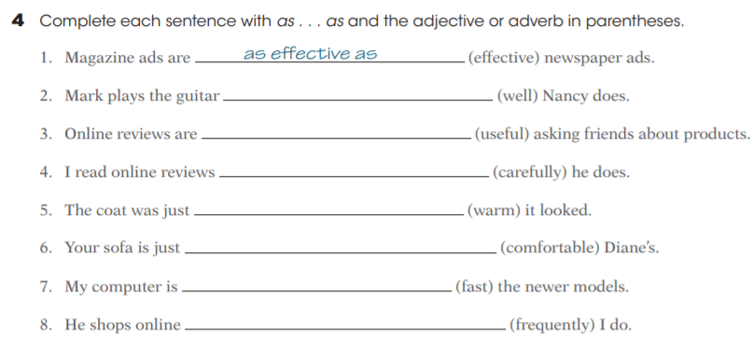
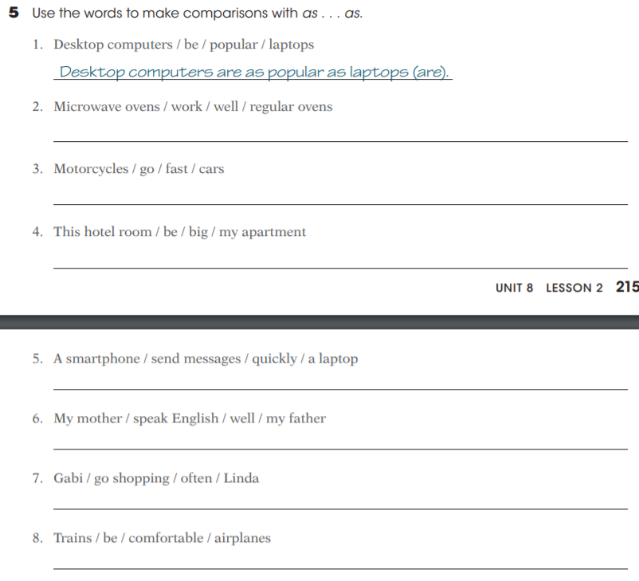

Past Simple or Past Continuous
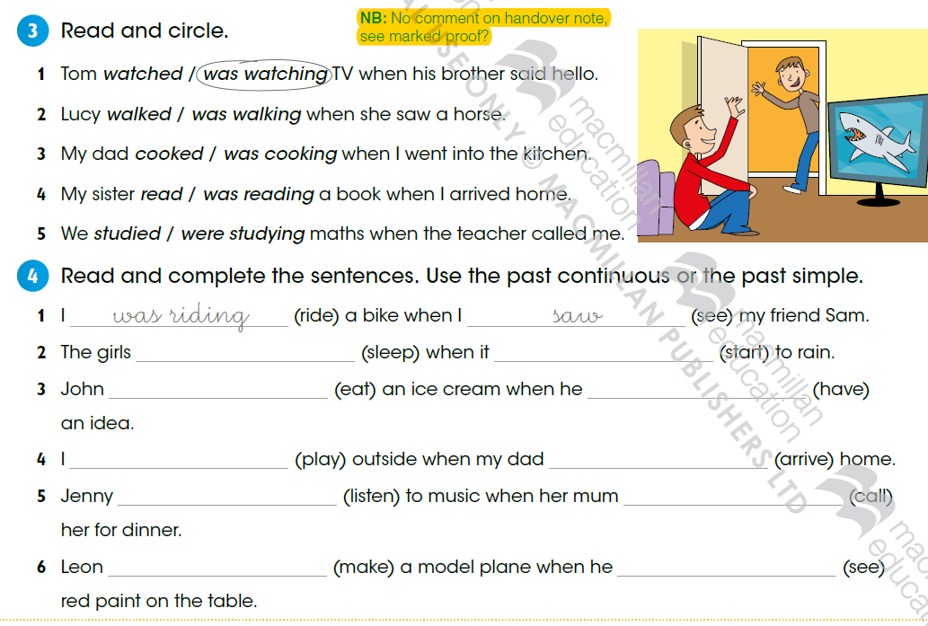
Test
- My friend…….a medal last week
a) not won
b) didn’t won
c) didn’t win
- Alice…….some fruit to school
a) taked
b) took
c) did take
- Ben and Tom ……….in the park 2 hours ago
a) weren’t
b) didn’t be
c) was
- What….in the basket?
a) he threw
b) did he threw
c) did he throw
- Andrew……play football yesterday
a) couldn’t
b) didn’t can
c) wasn’t can
- Kate……. With her dog at 6 p.m.
a) walked
b) did walk
c) was walking
- Phillip…………..his homework when he……….a noise outside
a) did/ heard
b) was doing/ heard
c) did/was hearing
- Where…….this book?
a) did you buy
b) did you bought
c) did/was hearing
- Fiona…………her door
a) didn’t can open
b) couldn’t opened
c) couldn’t open
- …………frightened of that huge dog yesterday?
a) did you
b) were you
c) was you

