EW4 суббота дз на 28 ноября
Учебник стр 38-39 читать и переводить текст, переводить все незнакомые слова. Тренировать чтение слов из списка слов по 3 юниту
Past Simple or Past Continuous
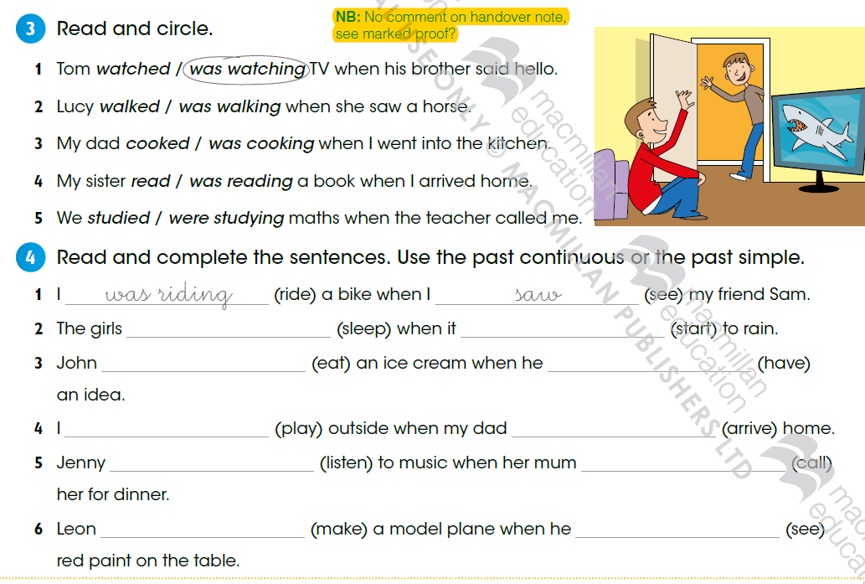
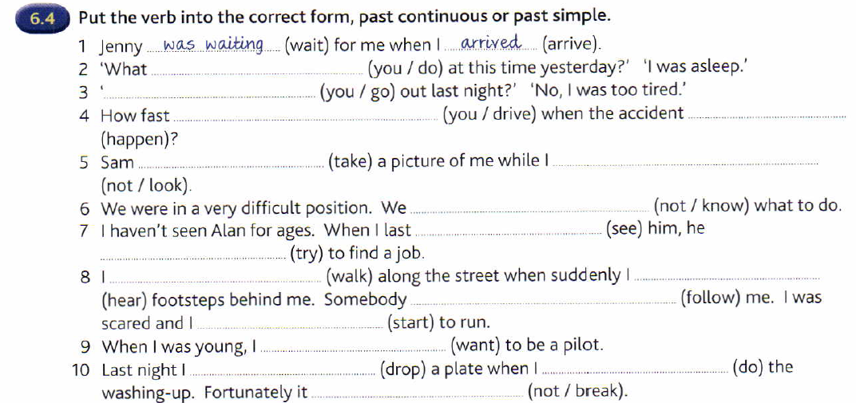
Past Simple and Past Continuous
1) When the post man (arrive), my father (have a shower)
2) While my brother (study), my grandma (make) some muffins
3) I (go) to the doctor 2 days ago because I (have) a terrible headache
4) When I (be) 10, I (eat) a sandwich every evening
5) He (miss) the train because he (talk) with some friends
6) The thieves (come) into the house while the man (sleep)
7) I (drink) a glass of water at eleven. I'm not thirsty now
8) you (write) the composition last week?
9) My mother (not/be) at home when she (fall) down the stairs
10) The children (plant) a tree when their mummy (call) them

1) Mr. Stevenson (drive) his car while he was listening to some music
2) Robert (type) the letter last week because his computer was broken
3) Louis fell asleep while he (study)
4) Lydia was drinking a glass of coke when Peter (come) in
5) While Michael was jogging , the dog (chase) him
6) Mrs. Parker (make) some muffins 2 days ago
7) Sam and Pam (ride) their bikes when they were small
8) Joe (run) as he was phoning his wife

