Homework: учим неправильные глаголы. Учим слова по юниту 3, дам итоговую работу. Повторить слова из юнитов 1, 2. Сделать здесь упражнения

Past Simple
1. I (break) my cup.
2. It (not/rain) yesterday.
3. (he/teach) Math on Monday?
4. (you/walk) to school yesterday?
5. She (go) to school late yesterday.
6. He (not/study) hard last year.
7. They (study) English at 8am this morning.
8. My mother (not/cook) dinner last night.
9. (they/work) hard yesterday?
10. She (not/sing) a song yesterday.
Past Simple and Past Continuous
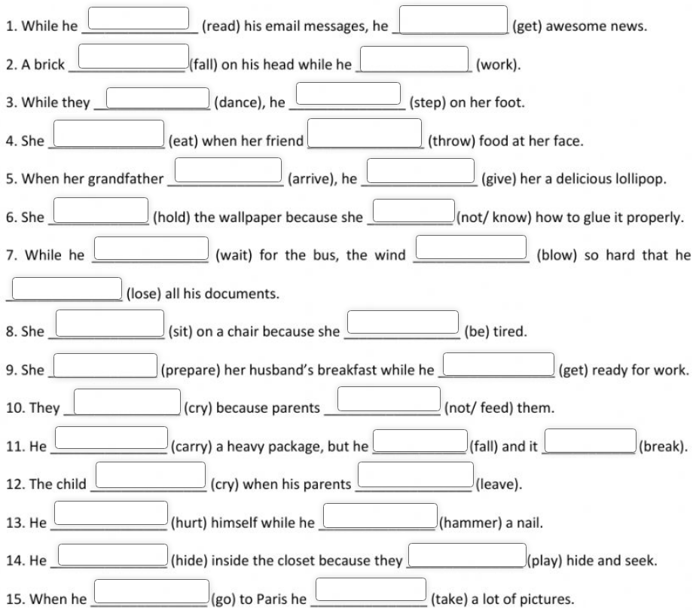
Past Simple and Past Continuous
