Вика
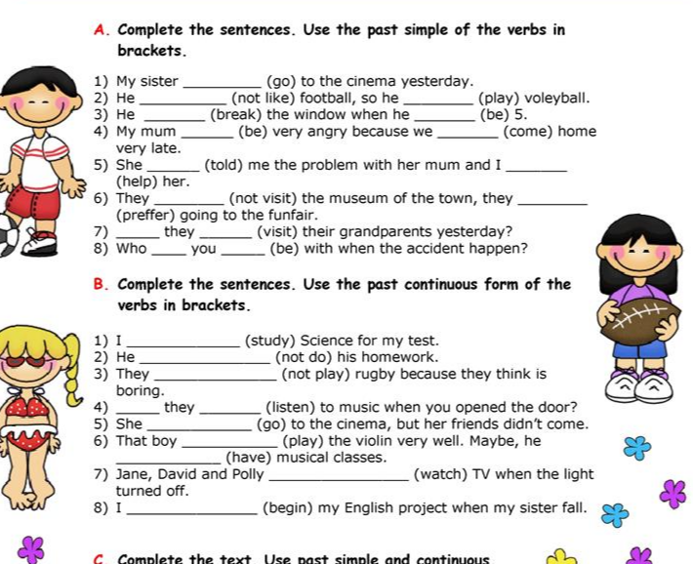
Раскройте скобки, употребляя глаголы в Past Simple.
1. My working day _________________ (to begin) at six o'clock.
2. I _________________ (to get) up, _________________ (to switch) on the TV and (to brush) my teeth.
3. It _________________ (to take) me about twenty minutes.
4. I _________________ (to have) breakfast at seven o’clock.
5. I _________________ (to leave) home at half past seven.
6. I _________________ (to take) a bus to the institute.
7. It usually_________________ (to take) me about fifteen minutes to get there.
8. Classes_________________ (to begin) at eight.
9. We usually _________________ (to have) four classes a day.
10. I _________________ (to have) lunch at about 2 o’clock

