EW4 Homework for 13 of October
- Повторяем слова юнит 1 и 2
- Составляем топик на 1 тему: My free time(school clubs) ---использовать слова по максимуму, выдумываем всё, что угодно, но чтобы вышло на 15 предложений с разнообразными словами из списка слов по 1 юниту

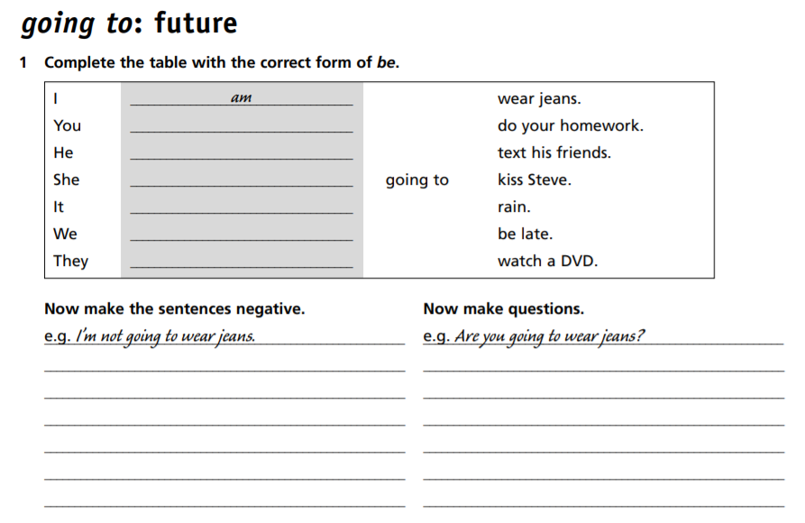
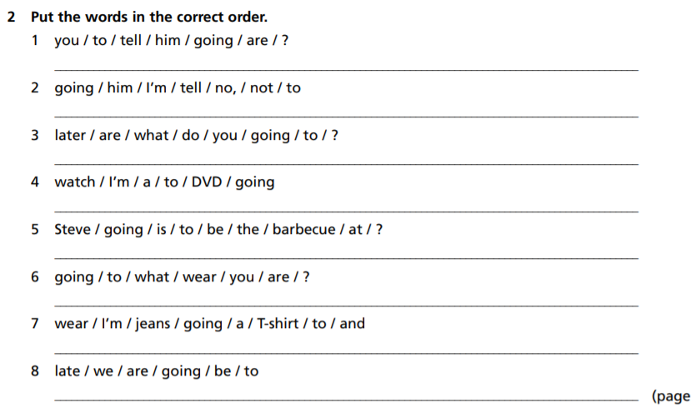

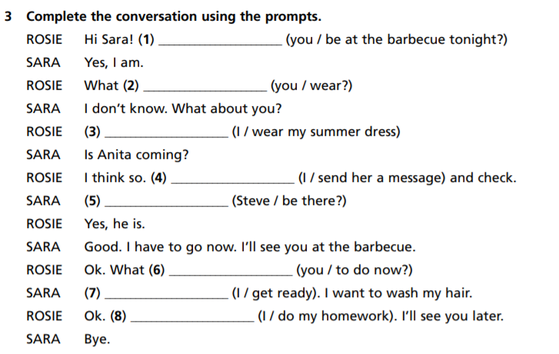
Упражнение 1. Перепишите следующий текст в прошедшем времени.
On Monday we have five lessons. The first lesson is English. At this lesson we write a dictation and do some exercises. Nick goes to the blackboard.
He answers well and gets a "five". Pete does not get a "five" because he does not know his lesson. After the second lesson I go to the canteen. I eat a sandwich and drink a cup of tea. I do not drink milk. After school I do not go home at once. I go to the library and take a book. Then I go home.
________________________________________________________________________________________________________________________________________________________________________________________________________________________________________________________________________________________________________
________________________________________________________________________________________________________________________________________________________________________________________________________________________________________________________________________________________________________
______________________________________________________________________________________________________________________________________________________________________________________________________________________________
Упражнение 2. Раскройте скобки, употребляя глаголы в Present или Past Simple.
1. I_______________ (go) to bed at ten o'clock every day.
2. I _______________ (go) to bed at ten o'clock yesterday.
3. My brother _______________ (wash) his face every morning.
4. Yesterday he_______________ (wash) his face at a quarter past seven.
5. I_______________ (not have) history lessons every day. 6. We _______________ (not rest) yesterday.
7. My brother _______________ (not drink) coffee yesterday.
8. My mother always _______________ (take) a bus to get to work, but yesterday she_______________ (not take) a bus. Yesterday she (to walk) to her office.
9. You _______________ ( talk) to the members of your family every day? - Yes, I .... But yesterday I _______________ (not talk) to them: I _______________(be) very busy yesterday.
10. You _______________ (come) home at six o'clock yesterday? - - No, I .... Yesterday I _______________ (come) home from school at half past eight. I _______________ (be) very tired. I _______________ (have) dinner with my family. After dinner I _______________ (be) very thirsty. I_______________ (drink) two cups of tea. Then I _______________ (rest).

Поставьте глаголы в следующих предложениях в утвердительную, вопросительную и отрицательную формы Past Simple.
1. I (do) morning exercises.___________________________________________________
_________________________________________________________________________
2. He (work) at a factory.___________________________________________________
_________________________________________________________________________
3. She (sleep) after dinner. ___________________________________________________
_________________________________________________________________________
4. We (work) part-time.___________________________________________________
_________________________________________________________________________
5. They (drink) tea every day. __________________________________________________
_________________________________________________________________________
6. Mike (be) a student.___________________________________________________
_________________________________________________________________________
7. Helen (have) a car. .___________________________________________________
_________________________________________________________________________
8. You (be) a good friend. .___________________________________________________
_________________________________________________________________________
9. You (be) good friends. .___________________________________________________
_________________________________________________________________________
10. It (be) difficult to remember everything.______________________________________
_________________________________________________________________________

