Настя
Требования к картинке
-Present Simple
- Present Continuous
- Present Perfect
- Past Simple
- Past Continuous
- Modal verbs ( can/have to/may/must)
- Future Simple
-to be going to
-The 1st Conditional
- Passive Voice

There are some people in the picture. They may be students. They have known each other for a long time, because they are chatting happily. I think they are getting ready for a test in the library. But before they were working at home. The test is difficult. If they pass the test, they will go to the cinema. They are going to have their test on Saturday. They have to read a lot of books. One girl is smiling. The boy who is wearing a green T-shirt is explaining something to the girls. He has already done his task, now he is trying to help his friends. Next week they won’t have any exams and they will go on a holiday.
These books were chosen and taken by the students in the library.

Home translation
- Мои братья по одному из родителей не очень ладят друг с другом. Они постоянно ругаются, потому что они из разных поколений. Моя тётя просто не выносит, когда они ругаются. Она надеется, что позднее они поладят
- Я заметил, что на тебе сейчас леггинсы. Где ты их купила?
- Мои племянники и племянницы отлично проводят вместе время. Они вместе сидят в интернете, играют в интерактивные игры, загружают фото и видео в интернет, болтают в чатах.
- Несомненно, стиль 80-ых был лучше. Все интересовались модой и носили узкие джинсы, у всех были татуировки, пирсинг, сумасшедшие причёски и крашеные волосы. Я бы хотел родиться в эти года
- Ты слишком много времени проводишь за компьютером. Ты входишь утром, а выходишь только вечером!

- What colour is Kathy’s bedroom now?
a) pink
b) green
c) blue
- Which platform does the woman’s train leave from?
a) 2
b) 6
c) 10
- How is Susan going to get to the airport?
a) by bus
b) by taxi
c) by train
- Which is Anna’s family?
a) mother tall, blond hair, father shorter, dark hair, brother 5 years younger
b) father tall, dark hair, mother shorter, blond, brother 5 years younger
c) father tall, dark hair, mother shorter, blond, brother 5 years older
- When is Kim’s birthday party?
a) June 11
b) June 16
c) June 30

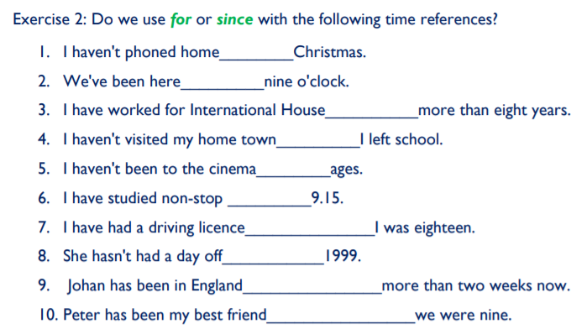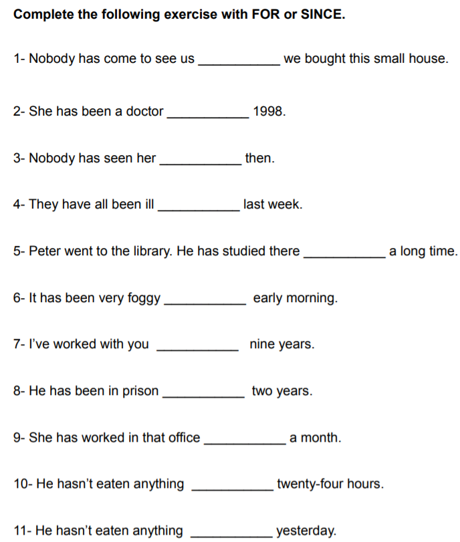
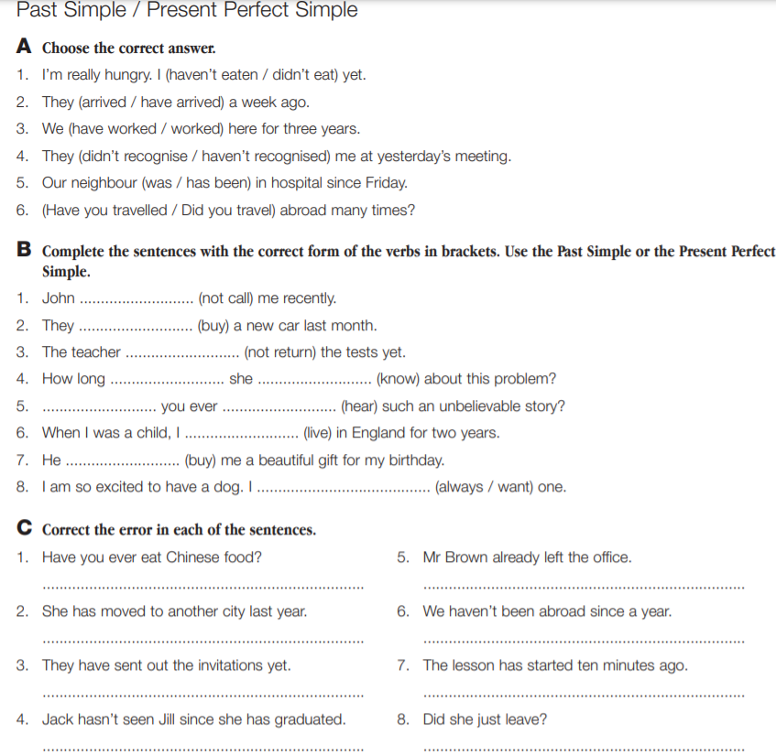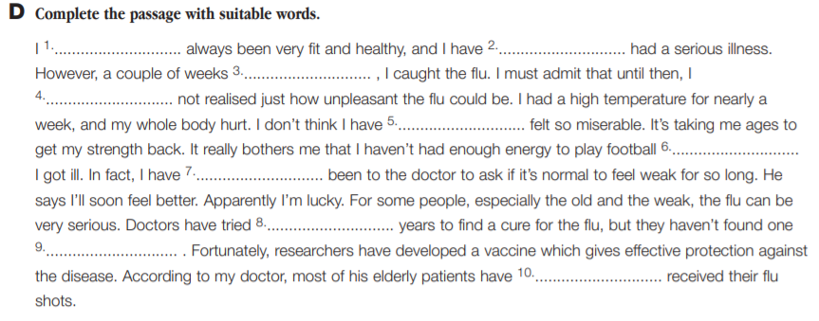
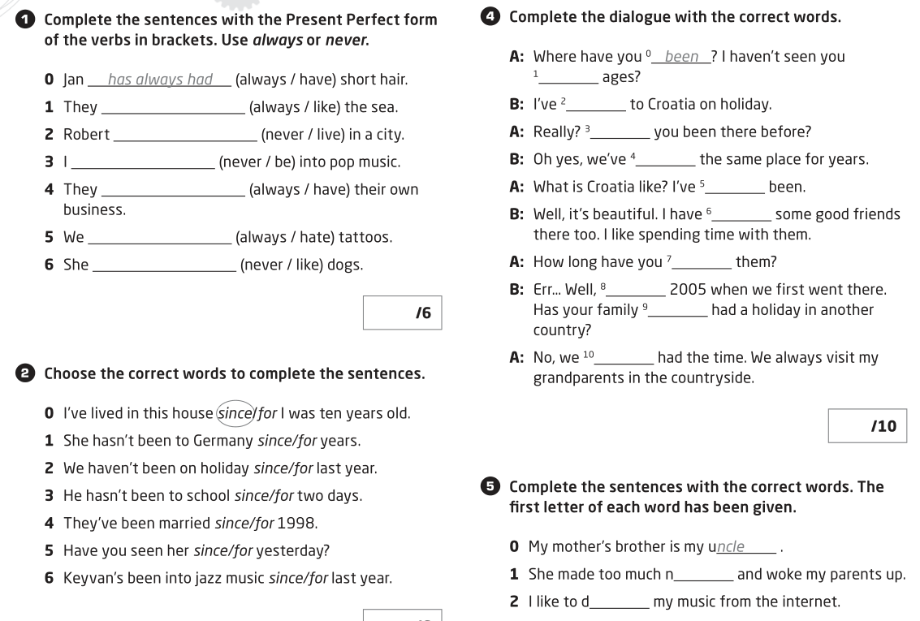
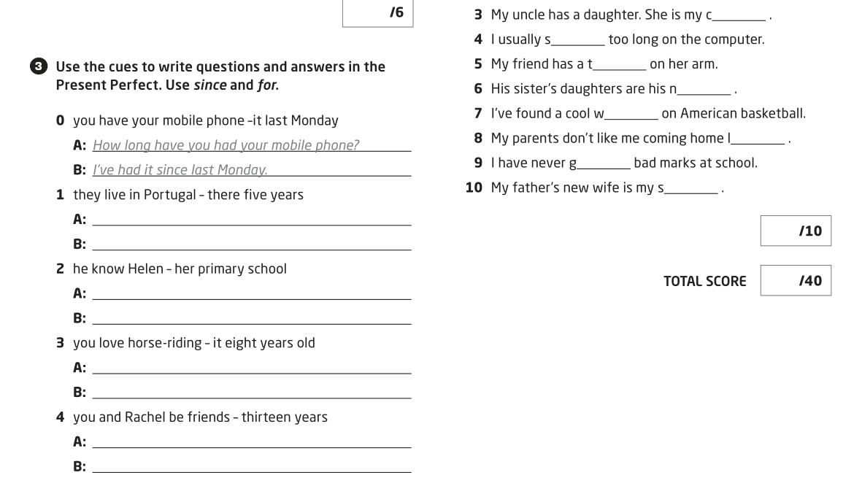

Final reading Unit 5
My uncle has already spent enormous amount of money on a new laptop. My stepbrother has just logged off the chat, I didn’t have time to tell him about you. He has fought with democratic parties whole his life. Were your children spending too long on the computer while you were travelling to incredible India? My niece has played interactive computer games for 7 hours every day! However, she has passed the test on excellent mark. We have surfed the net since morning and couldn’t find good jokes for our YouTube show.
Although my father in law has expressed his opinion on my previous hairstyle, I didn’t change it. My mother in law can’t stand tight jeans, she thinks they aren’t into fashion any more. Although they have done shopping for 8 hours already, they could find anything really amazing. There weren’t as tired as me. He has fallen in love with her since they were at university. She prefers baggy clothes. Have you noticed her new tattoo on the leg and piercing in the nose yet? They look horrible.
I have forgotten to email you. The queue was as long as the bridge. Has she had any arguments with her cousin, aunt and uncle? New generation loves to wear denim jackets, unusual hairstyle, dyed hair and buy expensive dresses and T-shirts. Although teenagers want new iPhones immediately, they sometimes can study hard to get it later. She has worn that ugly skirt since Monday. She was as noisy as your aunt.
My parents haven’t argued since they were married, except last month.
My nephew and I have had a great time together all our life. You have forgotten to take out rubbish since last weekend. I can’t stand it. However, I can do it, don’t worry. Has your niece got any pocket money since she left school? My previous teacher was as boring as this book. Have the fascist camps been horrible during the war? The natives of that island have had arguments with new citizens. Where was your half-brother born? My parents can’t stand all digital technologies.

